**Architecture Design Document for Power BI System**

**Introduction**

This document outlines the architecture design for analyzing Airbnb listing data using **Power BI**. The architecture focuses on data ingestion, processing, visualization, and delivery through Power BI Desktop, Service, and Mobile.

**What is an Architecture Design Document?**

An architecture design document provides a detailed blueprint of the system. It includes the components, data flow, communication paths, and deployment options. This document ensures stakeholders understand the entire setup and the relationships between each part of the system.

**Scope**

This architecture design document covers:

* **Data Acquisition** from various sources (Excel, databases).
* **Data Modeling & Preparation** in Power BI Desktop.
* **Report Publishing & Management** through Power BI Service.
* **Secure Data Access** using the Power BI Gateway.
* **Mobile Accessibility** using Power BI Mobile.
* **End-user Interactions** with dashboards through web and mobile interfaces.

**Architecture**

**Overview of Power BI Architecture Components**

1. **Power BI Desktop**
   * Used for data modeling, transformation, and report creation.
   * Connects to various data sources such as Excel, SQL, and APIs.
2. **Data Sources**
   * Raw data comes from **Excel files**, **SQL databases**, or **cloud sources** (like Azure, Google Sheets).
   * Data can be refreshed periodically for up-to-date analysis.
3. **Power BI Gateway**
   * Securely connects on-premises data sources to Power BI Service.
   * Allows real-time or scheduled data refresh between Power BI Service and on-prem data sources.
4. **Power BI Service**
   * Cloud-based platform to publish and share reports and dashboards.
   * Provides collaboration tools and scheduled refresh capabilities.
5. **Power BI Mobile**
   * Mobile app to access published reports on the go.
6. **Users & Consumers**
   * Stakeholders access dashboards through Power BI Service via web or mobile platforms.
   * Real-time insights empower decision-making.

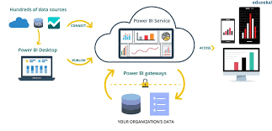

**Power BI Architecture**

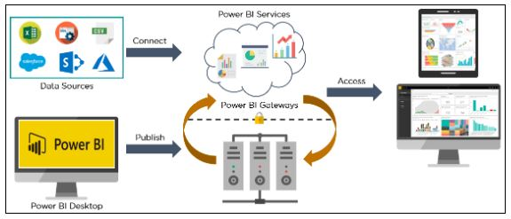

Power BI architecture is a service built on top of [Azure](https://www.simplilearn.com/tutorials/azure-tutorial). There are multiple data sources that Power BI can connect to. Power BI Desktop allows you to create reports and data visualizations on the dataset. Power BI gateway is connected to on-premise data sources to get continuous data for reporting and analytics. Power BI services refer to the cloud services that are used to publish Power BI reports and data visualizations. Using Power BI mobile apps, you can stay connected to their data from anywhere. Power BI apps are available for Windows, iOS, and Android platforms.

**Power BI Communication Flow**

1. **Data Flow**:
   * Data from sources (Excel, SQL, etc.) flows into Power BI Desktop for transformation.
   * Reports are published from Desktop to Power BI Service.
2. **Service Interaction**:
   * Power BI Service interacts with the Gateway for secure data refresh.
   * Users access the reports either via web (Power BI Service) or mobile apps (Power BI Mobile).
3. **Gateway Usage**:
   * The Gateway ensures data from on-prem sources flows securely to the cloud without direct exposure.



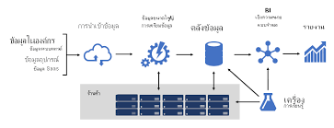

**Deployment**

**Deployment Options in Power BI**

**Single Node Architecture**

* All components (Desktop, Gateway, Service) work on a single machine.
* Suitable for small-scale deployments with limited data and users.

**Three Node Architecture**

* Separate nodes for Power BI Desktop, Gateway, and Service.
* Ensures better load distribution and scalability.
* Recommended for mid-sized organizations needing regular refresh and collaboration.

**Five Node Architecture**

* Distributed setup with multiple nodes for Desktop, Gateway, and Power BI Service instances.
* Ideal for large organizations with high data volume and concurrent users.